Group 3

**InPress**

**User Manual**

Abdul Hadi Muhammad (0951862)

Liu Wenbo (0970709)

Justin Kan (0843763)

Copyright © 2014 InPress

Revision 1.0.0.0

# **Legal and Copyright Information**

**This User Manual is published by InPress. InPress can make any improvements and changes to this document at any time. This includes correction to typographical errors, improvements to software, and inaccuracies of current information.** Such changes will, however, be incorporated into new editions of this User guide.

All product and company names mentioned herein are the trademarks or registered trademarks of their respective owners. Any rights not expressly granted herein are reserved. All other trademarks are property of their respective owners. It is against the law to copy the software on any medium except as specifically allowed in the license or nondisclosure agreement.

Visit <inpress.mcmaster.ca> for more information. All illustrations are for illustration only and may not accurately depict the actual accessory.

InPress copyright © 2014, InPress All rights reserved

Table of Contents

Legal and Copyright Information 2

Introduction 5

Getting Started 5

1.0 Provisioning the Server 5

# **List of Tables & Figures**

# Introduction

InPress is a web-based application, which allows students in universities and colleges to respond real time to questions posted by their instructor. It provides a complete, multiplatform application, which is supported on all internet-enabled devices including tablets, and mobile phones. The intended goal is to improve student engagement in the class using the latest technologies.

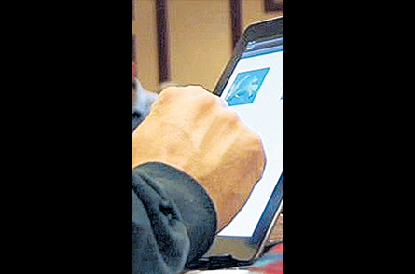

Instructor

Figure 1: Outline of how InPress is used

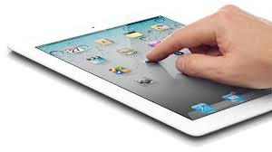

Students

3G, 4G, LTE, WiFi

Instructor

This User Manual is intended as an aid to those who need to install, and configure InPress. It does not delve into many of the more technical aspects of the code. A separate InPress document (Design Document) outlines those technical parts.

# Getting Started

Prior to using InPress, a server hosting the application must be provisioned. This server must be accessible to all students in the class.

## 1.0 Provisioning the Server

1. Ensure that the server contains one of the following Operating Systems – Mac OS X ®, Microsoft Windows ®, or Linux®
2. Install the following packages on the server
   1. Python (<http://www.python.org/downloads/>)
   2. Django (<https://docs.djangoproject.com/en/1.6/intro/install/>)

System Administrator:

* build up the server
  + The server can be Mac OS, windows and Linux
  + Please install python on the server, download link: <http://www.python.org/downloads/>
* install django
  + Inpress needs to run on django environment, please use this link and guide to install django on the server. <https://docs.djangoproject.com/en/1.6/intro/install/>
* configure database
  + InPress is using the Postgres SQL as database. Please install Postgres from the link provided: <http://www.postgresql.org/download/>
  + Create an administrator account “postgres” in postgres SQL.
  + Create a new databse under the same default server, name it as “inpressdb", use postgres as account manager.
* copy the zip file and release the files to the location
  + If user already have postgres configured before and have a different administrator account. Please go to “setting.py” located inside the “inpress” folder. Please put the credentials for the database and user account into the Database function at line 11.
* Locate the “manage.py” file
  + Type in the code in command promt: python manage.py syncdb
    - If the command doesn’t working, please go back to setting.py check the credentials listed about database and make sure the database is created already.
  + Django will ask user for manage account, at first time syncdb. Please type in the credentials that will going to be used in later on maintenance.
  + Type the code in the command promt: python manage.py runserver PortNumber
    - PortNumber is the port number user want to use for Inpress.
  + Open the browser, go to the “server address:PortNumber/admin”
    - Enter the credentials user defined while first time syncdb.
    - Click on Instructor table
    - Add new one
    - Add the Instructor credentials
    - Save